Problem Assignment #4
Instruction Sequencer Finite State Machine
ECE 2330 Digital Logic Design
Spring 2022
March 18, 2022
By Kevin Moody (km4ws)

Table of Contents
1 Problem Statement 2
2 Analytical Design 3
3 Numerical Verification 4
4 Summary 5

Table of Figures
Figure 1: Simple CPU Sequencer FSM State Transition Table 2
Figure 2: Output Table for Timing Pulses 2
Figure 3: Output Table for Execute 2
Figure 4: Outer Circuit for InstructionSequencerFSM 3
Figure 5: Inner Circuit for InstructionSequencerFSM 3
Figure 6: ClearLogic Circuit 3
Figure 7: 3-Bit Binary Counter Circuit 3
Figure 8: OutputLogic Circuit 3
Figure 9: FSM State Transition Diagram 3
Figure 10: ClearLogic Equations 3
Figure 11: 3-Bit Binary Counter Equations 3
Figure 12: OutputLogic Equations 3
Figure 13: ClearLogic Vectors 4
Figure 14: 3-Bit Binary Counter Vectors 4
Figure 15: OutputLogic Vectors 4
Figure 16: InstructionSequencerFSM Vectors 5
Figure 17: InstructionSequencerFSM Graph Results 5

1 Problem Statement
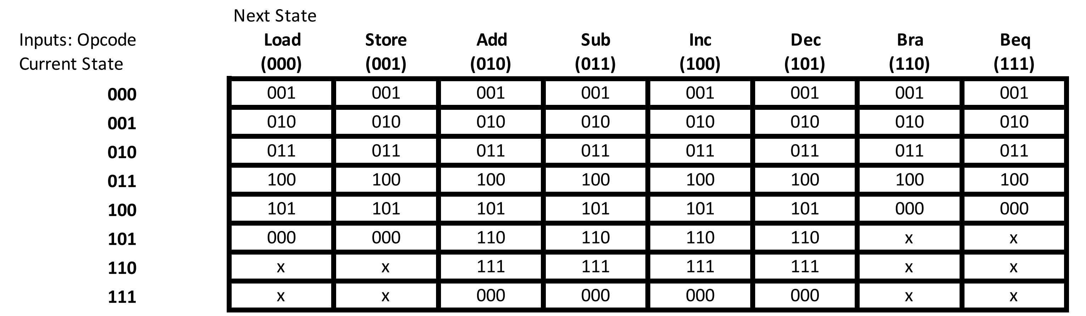
Design a circuit to generate the instruction sequencing signals used to ensure the proper sequencing of the control signals generation for instruction fetch and execute. The circuit is a Finite State Machine (FSM) that takes in the 3-bit opcode and requires 3 sequential elements to store the current state. A state transition table for circuit is shown in Figure 1.
Figure 1: Simple CPU Sequencer FSM State Transition Table
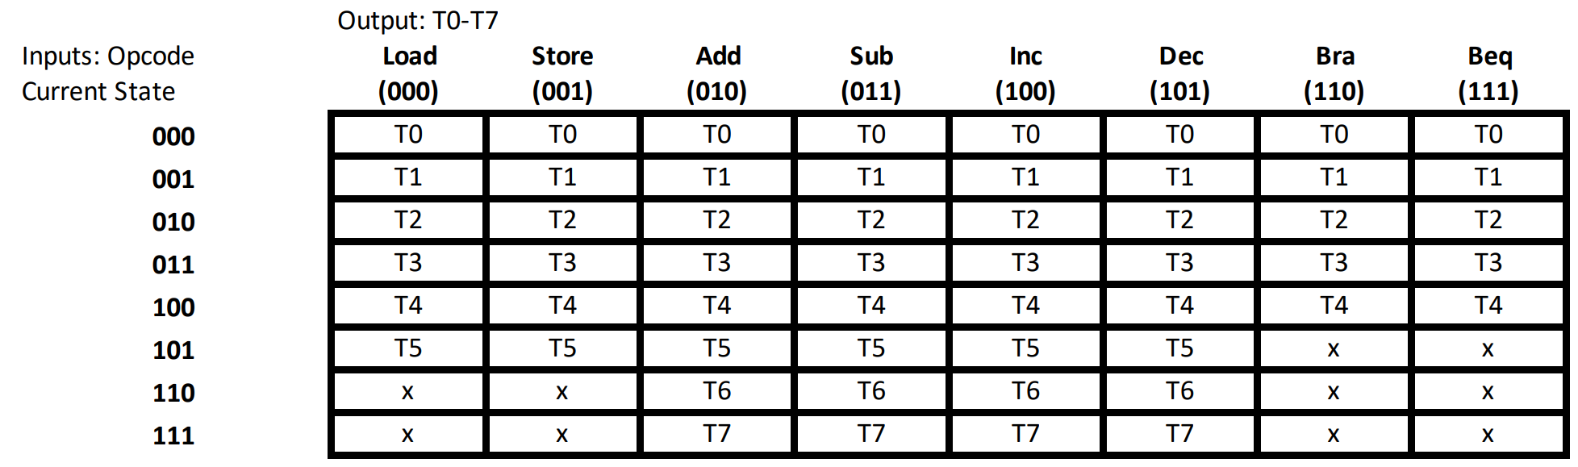
This circuit will generate the 8 timing pulses used to sequence the instruction fetch and execute operations. The output table for the timing pulses is shown in Figure 2 for the 8 instructions.
Figure 2: Output Table for Timing Pulses
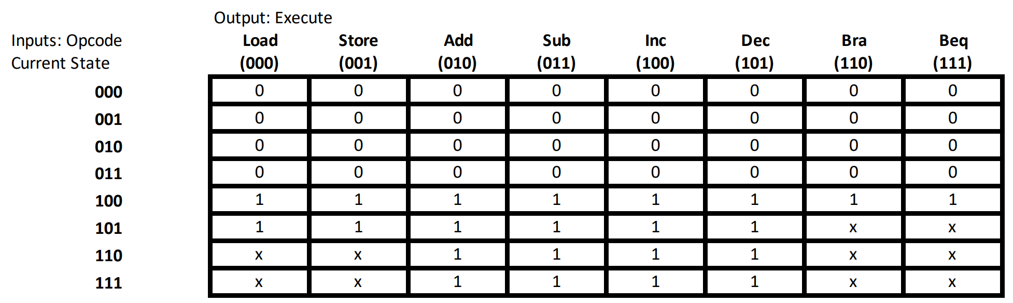
The circuit should also generate a signal to indicate when an instruction is being fetched and when it is being executed. Execute will equal 0 during pulses T0-T3 to indicate the instruction is being fetched and will equal 1 for the remainder of timing pulses to indicate the execution of the current instruction. The output table for Execute is shown in Figure 3.
Figure 3: Output Table for Execute

2 Analytical Design
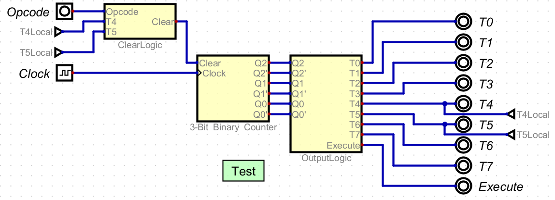
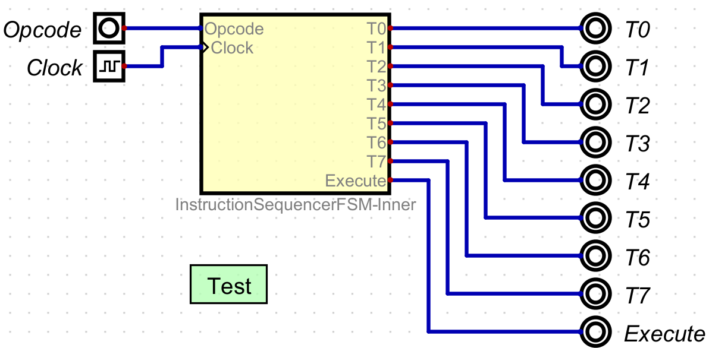
The outer and inner circuit schematics for the InstructionSequencerFSM are shown in Figures 4 and 5 respectfully. The yellow box in the outer circuit contains the schematic shown in the inner circuit. The test cases in these two circuits are identical and will be discussed later.
Figure 5: Inner Circuit for InstructionSequencerFSM
Figure 4: Outer Circuit for InstructionSequencerFSM
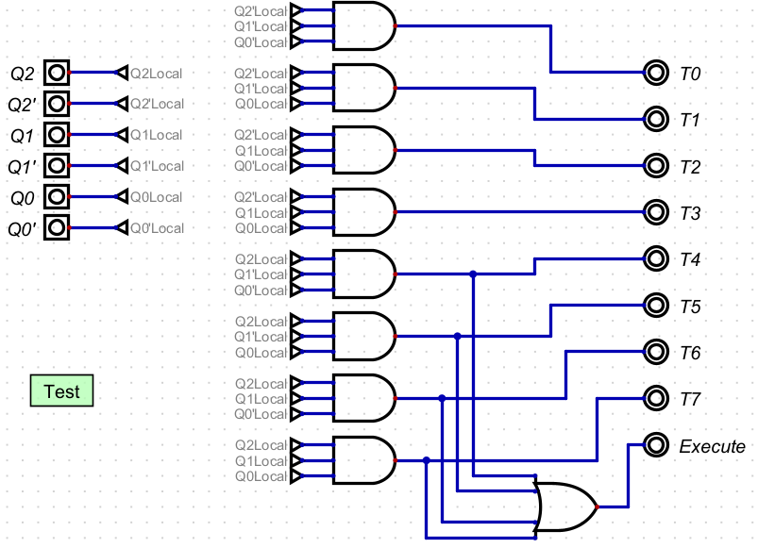
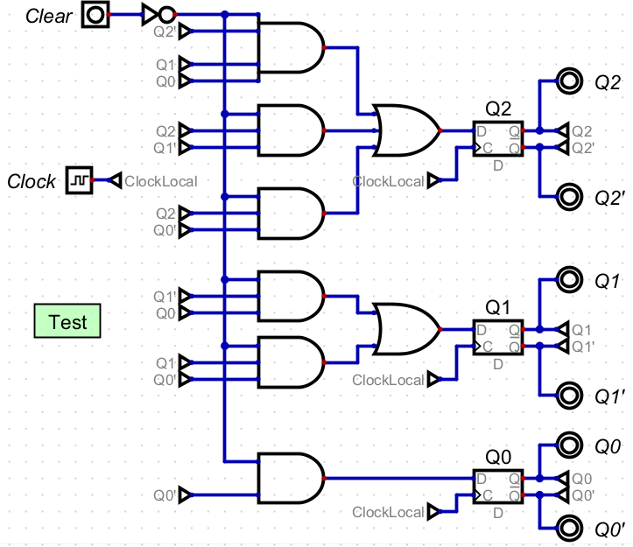
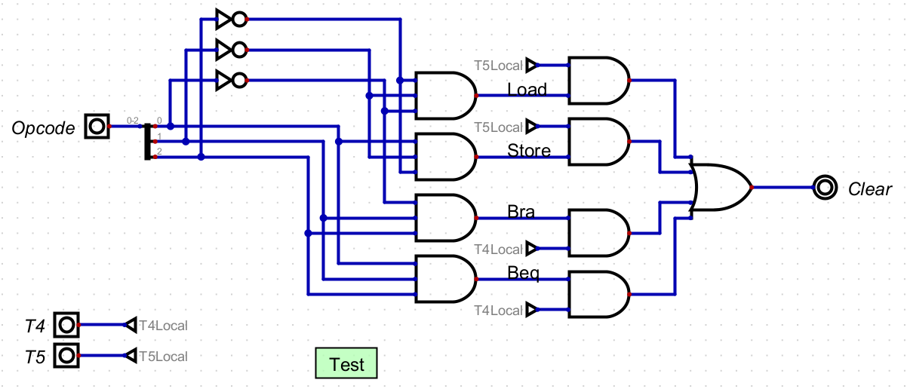
Additionally, 3 circuits were created in the Inner Circuit. These circuits are titled ClearLogic, 3-Bit Binary Counter, and OutputLogic, and are shown below in Figures 6, 7, and 8.
Figure 7: 3-Bit Binary Counter Circuit
Figure 8: OutputLogic Circuit
Figure 6: ClearLogic Circuit
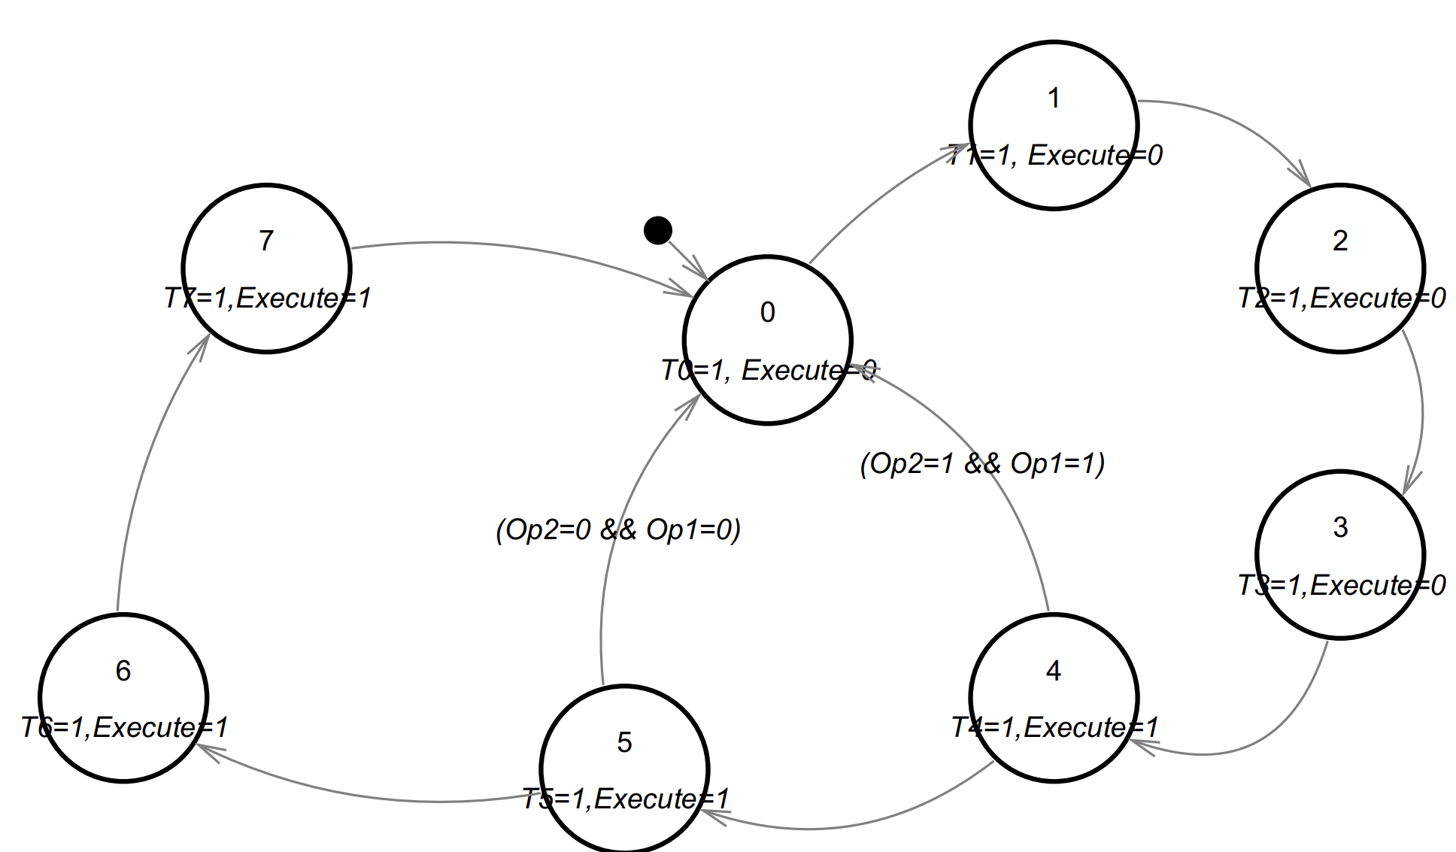
Figure 9: FSM State Transition Diagram
Shown in Figure 9 is the FSM State Transition
Diagram, which was used in conjunction with Figures 1-3 to create the equations shown in Figures 10-12. These equations were derived using the priniciples of circuits, finite state machines, and properties of sequential circuits.
Figure 12: OutputLogic Equation
Figure 11: 3-Bit Binary Counter Equation
Figure 10: ClearLogic Equation
Clear = Opcode1’ Opcode2’ T5+Opcode1 Opcode2 T4 | Q2^{n+1} = Clear’Q0^{n}Q1^{n}Q2’^{n} + Clear’Q1’^{n}Q2^{n} + Clear’Q0’^{n}Q2^{n}  Q1^{n+1} = Clear’Q0^{n}Q1’^{n} + Clear’Q0’^{n}Q1^{n}  Q0^{n+1} = Clear’Q0’^{n}  Q2 = Q2^{n}  Q2’ = Q2’^{n}  Q1 = Q1^{n}  Q1’ = Q1’^{n}  Q0 = Q0^{n}  Q0’ = Q0’^{n} | T0 = Q2’ Q1’ Q0’  T1 = Q2’ Q1’ Q0  T2 = Q2’ Q1 Q0’  T3 = Q2’ Q1 Q0  T4 = Q2 Q1’ Q0’  T5 = Q2 Q1’ Q0  T6 = Q2 Q1 Q0’  T7 = Q2 Q1 Q0  Execute = Q2

3 Numerical Verification
The overall InstructionSequencerFSM was tested with a large quantity of test vectors, as well as each of the embedded circuits ClearLogic, 3-Bit Binary Counter, and OutputLogic. Looking at ClearLogic first,
the “Clear” output is intended to revert the state machine back to state 0 (Q2’, Q1’, and Q0’, and T0) in two cases: In state T4, when Op2 and Op1 both equal 1, and in state T5, when Op2 and Op1 both equal 0. The equation in Figure 7 shows this, and the test vectors verify it in Figure 11. Next is the 3-Bit Binary Counter, which involves numerous D Flip-Flops in order to progressively generate the next Q2, Q1, and Q0 values as well as their complements. Our test vectors show that if we run the clock input, the Q values will progressively climb from 000 to 111 in binary (and their complements vice versa), and will be set to 0 when Clear is set to 1. Next is the OutputLogic, which takes in the Q states from the binary counter and uses them to generate which T value will be set to 1. Remember that the binary counter will sequentially count up to 8 in binary using the Q states, then reset back to 0, progressing on every clock cycle. The test vectors prove that for each Q state from 0-7 in binary, will generate the equivalent T state from 0-7. Additionally, whenever Q2 is 1, the execute signal will be 1 as well (this occurs between T4-T7).

Finally, the test vectors for the InstructionSequencerFSM. The test vectors used attempted to imitate a typical oscillating Clock signal, as well as the Opcode (3 bits) progressing from 0 to 7. As described in the Problem Statement, signals T0-T4 should always be sequentially generated no matter what the opcode is. Execute should be equal to 1 whenever T4-T7 is equal to 1. For Opcodes 1 and 2, only T0-T5 should be generated. For Opcodes 2-5, all T values should be generated sequentially. For Opcodes 6 and 7, only T0-T4 should be generated. The test vectors verify these results.

The results for all of these test vectors are shown below. Test vectors may be cut off for brevity but can be observed in their respective .dig files.
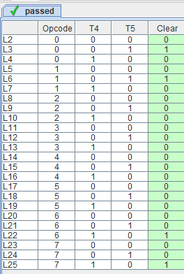
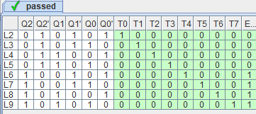
Figure 15: OutputLogic Vectors
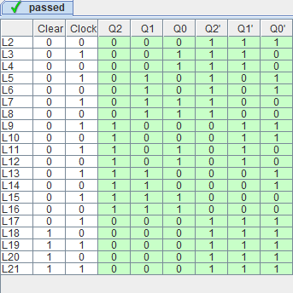

Figure 13: ClearLogic Vectors
Figure 14: 3-Bit Binary Counter Vectors

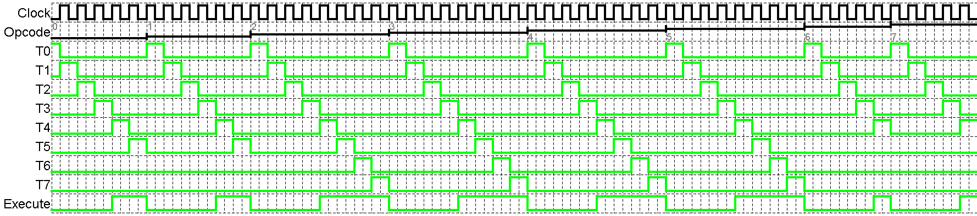
Figure 16: InstructionSequencerFSM Vectors
Figure 17: InstructionSequencerFSM Graph Results
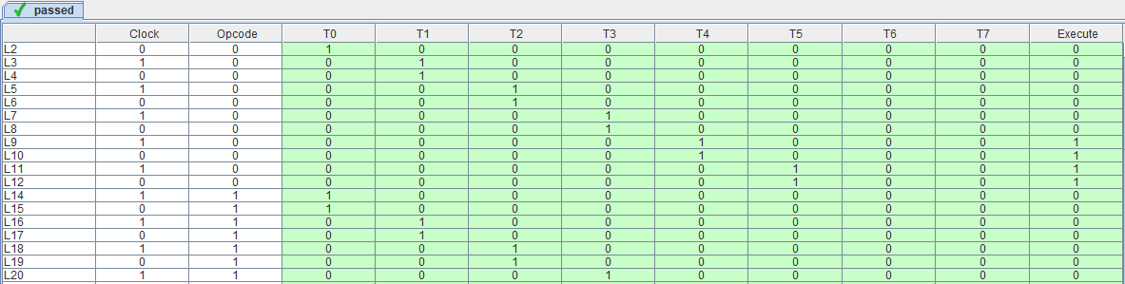
4 Summary
The problem requirement for this assignment was to generate the instruction sequencing signals used to ensure proper sequencing of the control signals generation for instruction fetch and execute. This was done by combining three embedded circuits, ClearLogic, 3-Bit Binary Counter, and OutputLogic. The circuit is a FSM with 3 inputs which required 3 sequential elements to store the state, represented as Q2, Q1, and Q0. Three equations, one for each of the embedded circuits, were developed using the figures provided in the projected assignment, which was then used to design a digital circuit solution. The circuit solution was then tested with 4 sets of test vectors, one for each embedded circuit, and one for the overall circuit. Therefore, the digital circuit design solution satisfies the project requirements.

